**PRN: 085 Rupesh Kamble**

1. **Git Repository :**

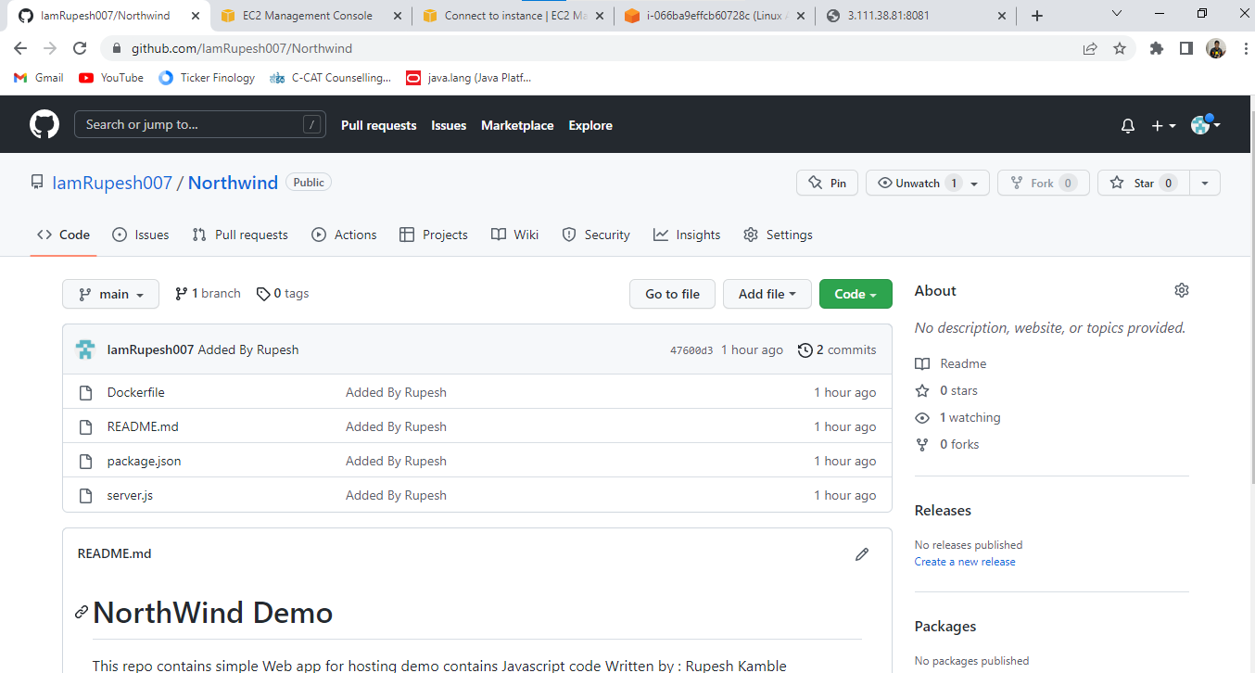

1. **AWS Server :**

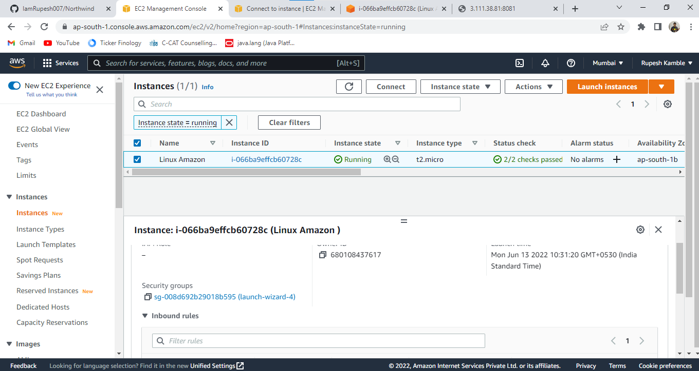

1. **Clone GitHub Northwind code repository to your Developer machine using git command**

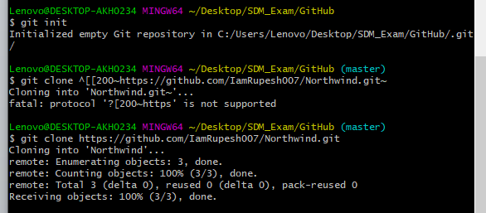

1. **Runnning Docker :**

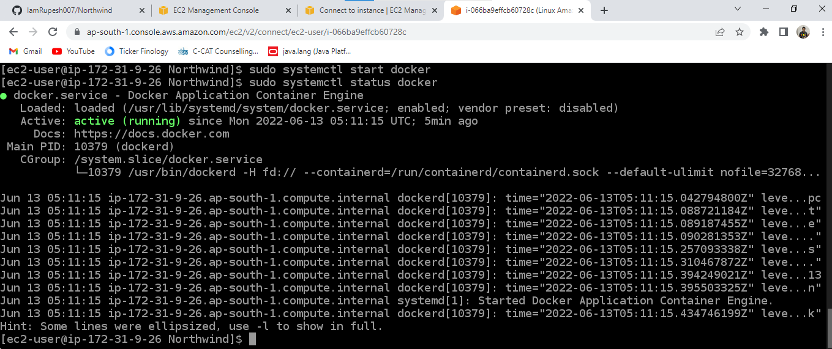

1. **Hosted website:**

